**USER MANUAL**

**NCVT MIS SPIU Trainee Discharge**

**STEP – 1:-** Open NCVT site using the URL, <https://ncvtmis.gov.in/pages/home.aspx>

**STEP – 2:-** Click the **Login** Link on page

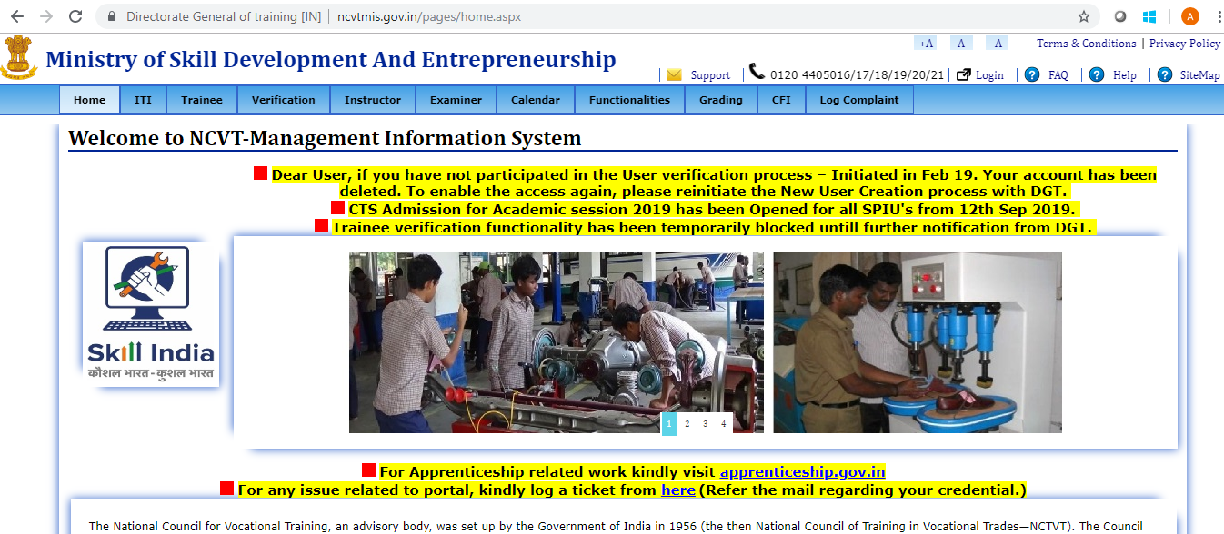

**STEP – 3**:- Login with SPIU credentials.

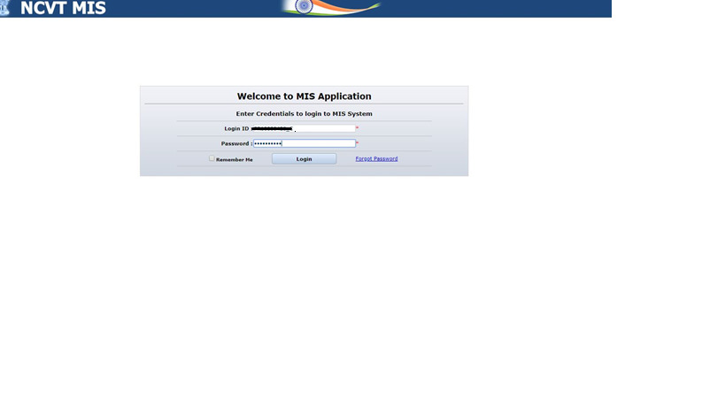

**STEP – 4**:- Navigate to the below path:**-**

**Menu🡪 SPIU🡪 Academic 🡪 Admitted Trainee 🡪 Edit Trainee**

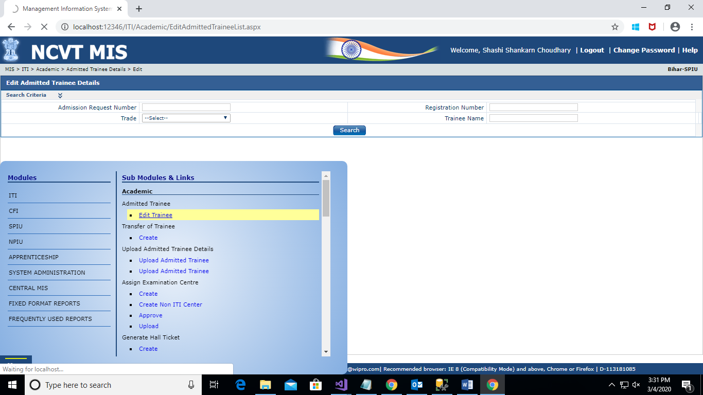

**STEP – 5**:- Following screen will appear on Edit Trainee menu clicked, fill the trainee registration number and click on “Search” button. SPIU_XA role should be assigned to the SPIU for this functionality, if not then please contact to NPIU for getting this role.

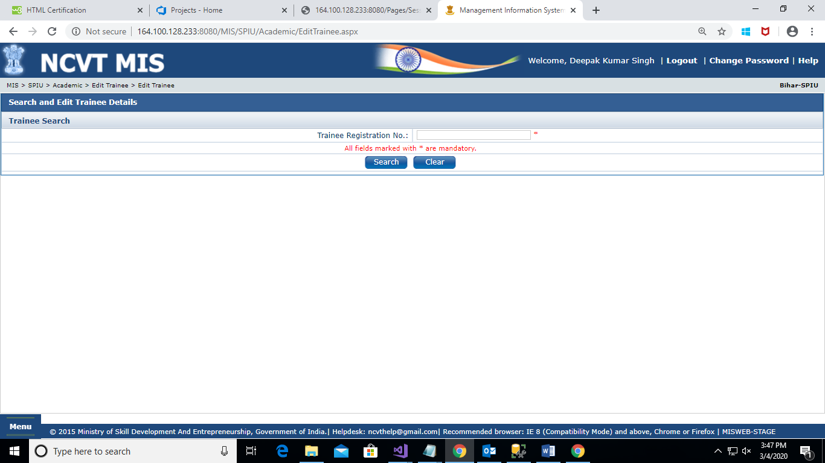

**STEP – 6**:- Trainee details will appear on Trainee Edit section as shown in the screen below. Registered Trainee Registration number required here is, not the admission request number. Only approved trainee can be discharged.

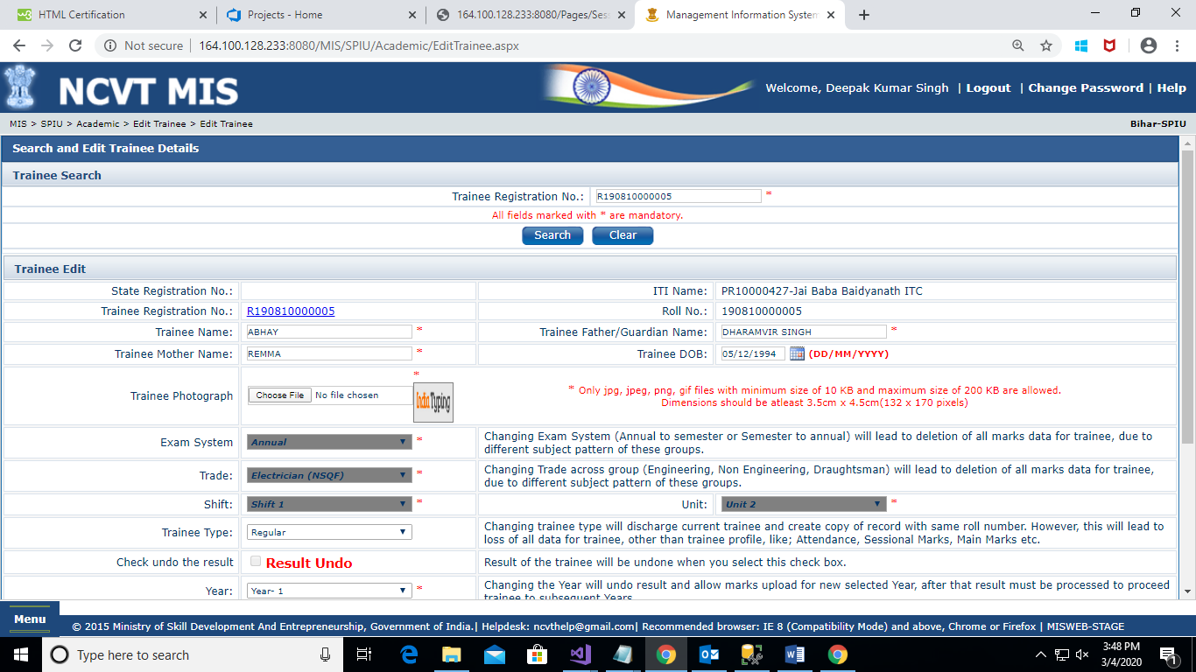

**STEP – 6**:- checked the checkbox “check to Discharge a trainee” and click on Submit button as shown in the screen below.

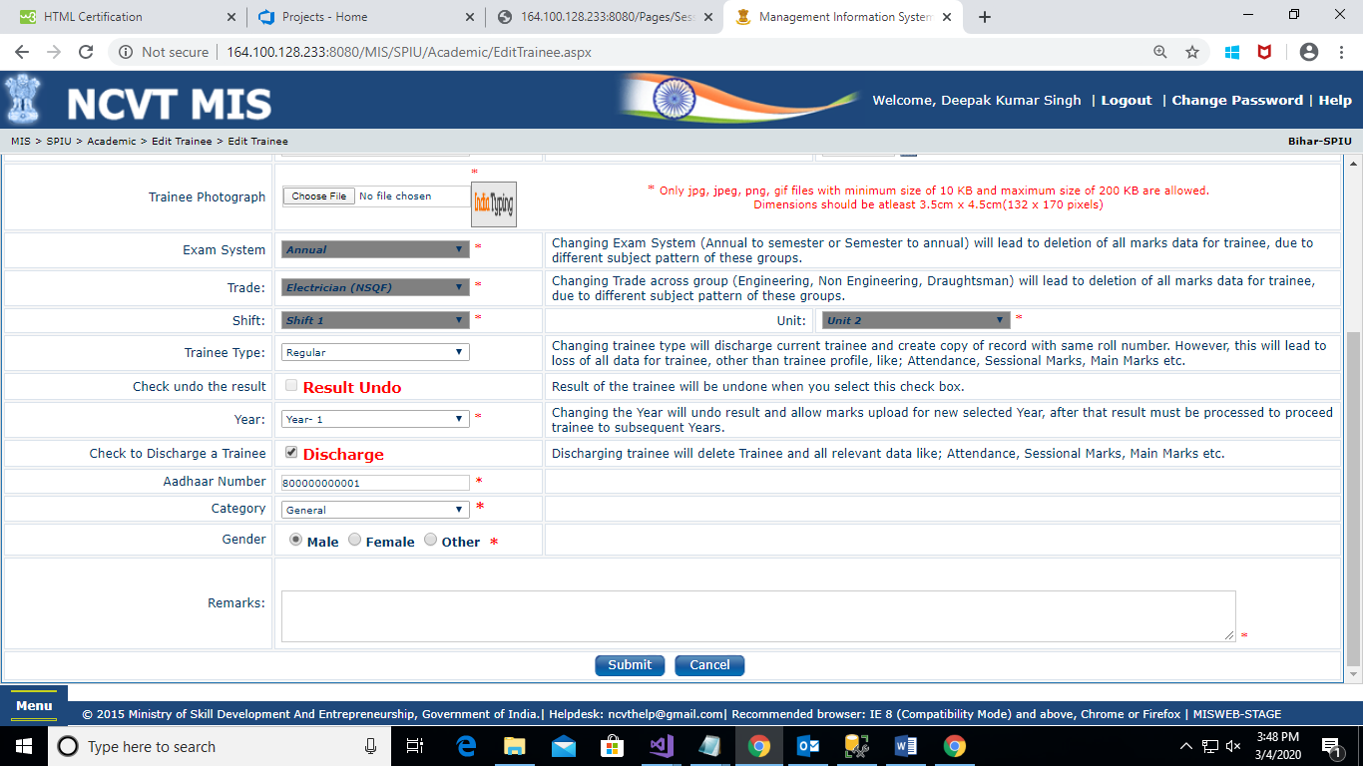

**STEP – 7**:- Confirmation message “Are you sure you want to Discharge Trainee? This will delete complete data of trainee from MIS system will be displayed, click on OK button of confirmation message and click on Submit button as shown in the below screen.

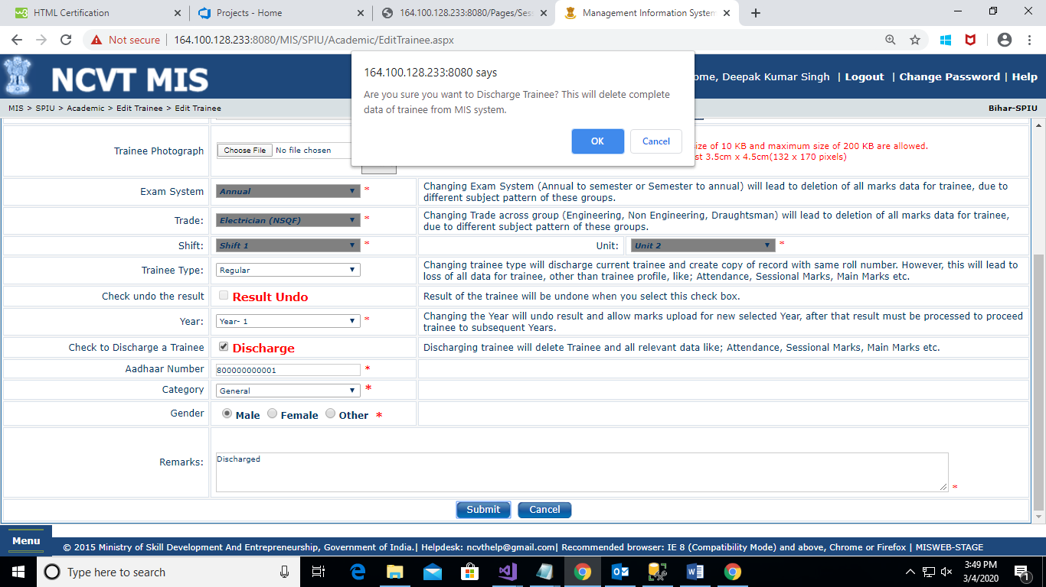

**STEP – 8**:- OTP verification screen will be displayed, enter the OTP number received on your registered number and click on Submit button as shown in the below screen.

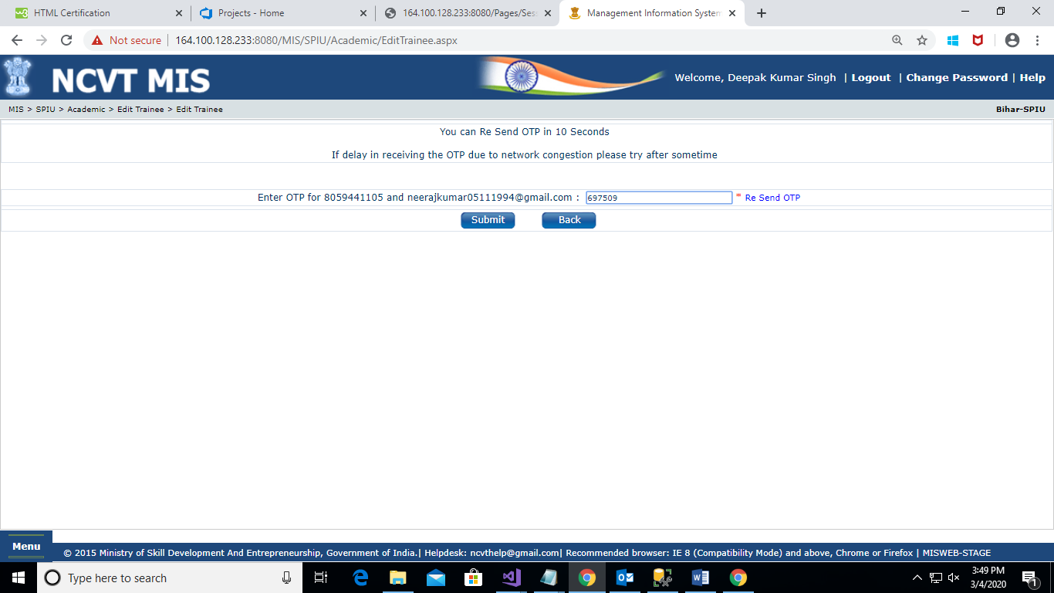

**STEP – 9**:- Trainee details updated successfully message will be displayed on successful discharged of the trainee as shown in below screen.

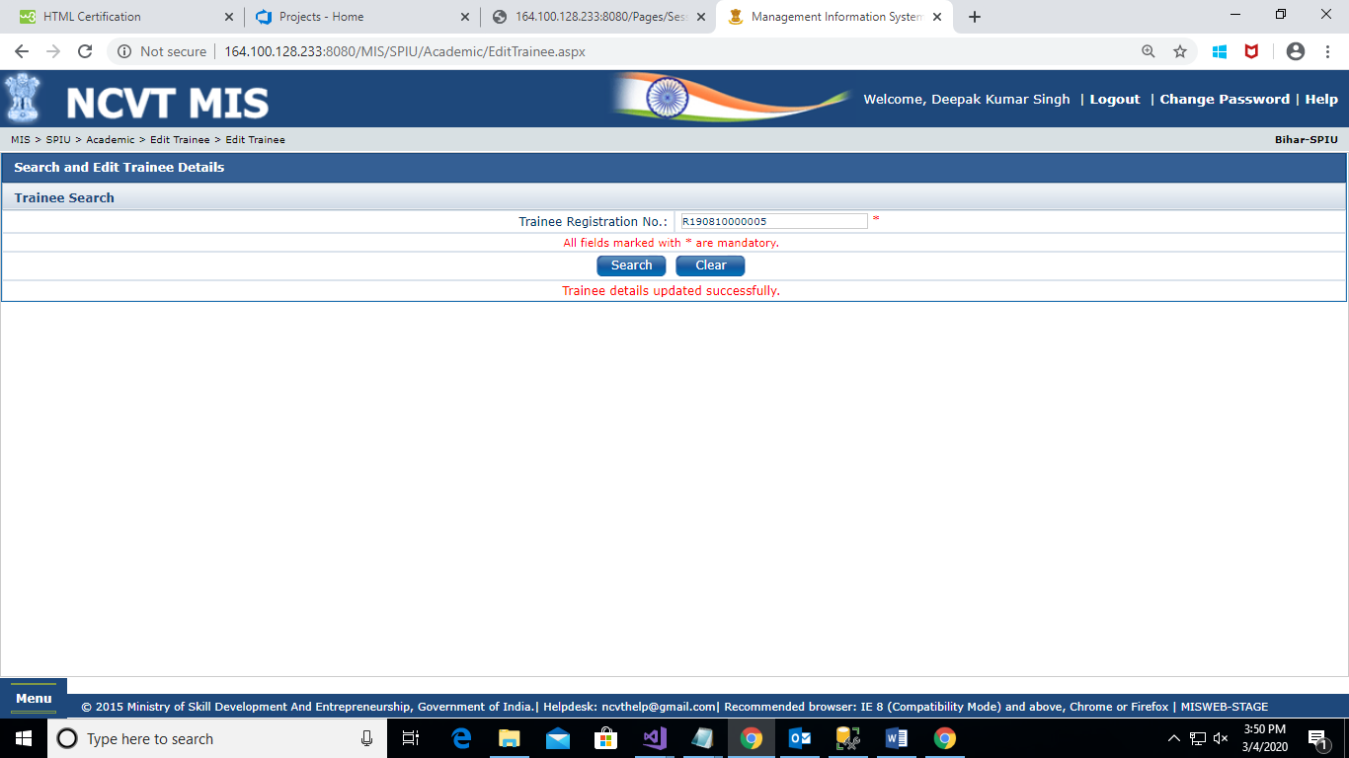

**End Functionality**